**Assignment 3 & Assignment 4**

1. **a)** Accessing API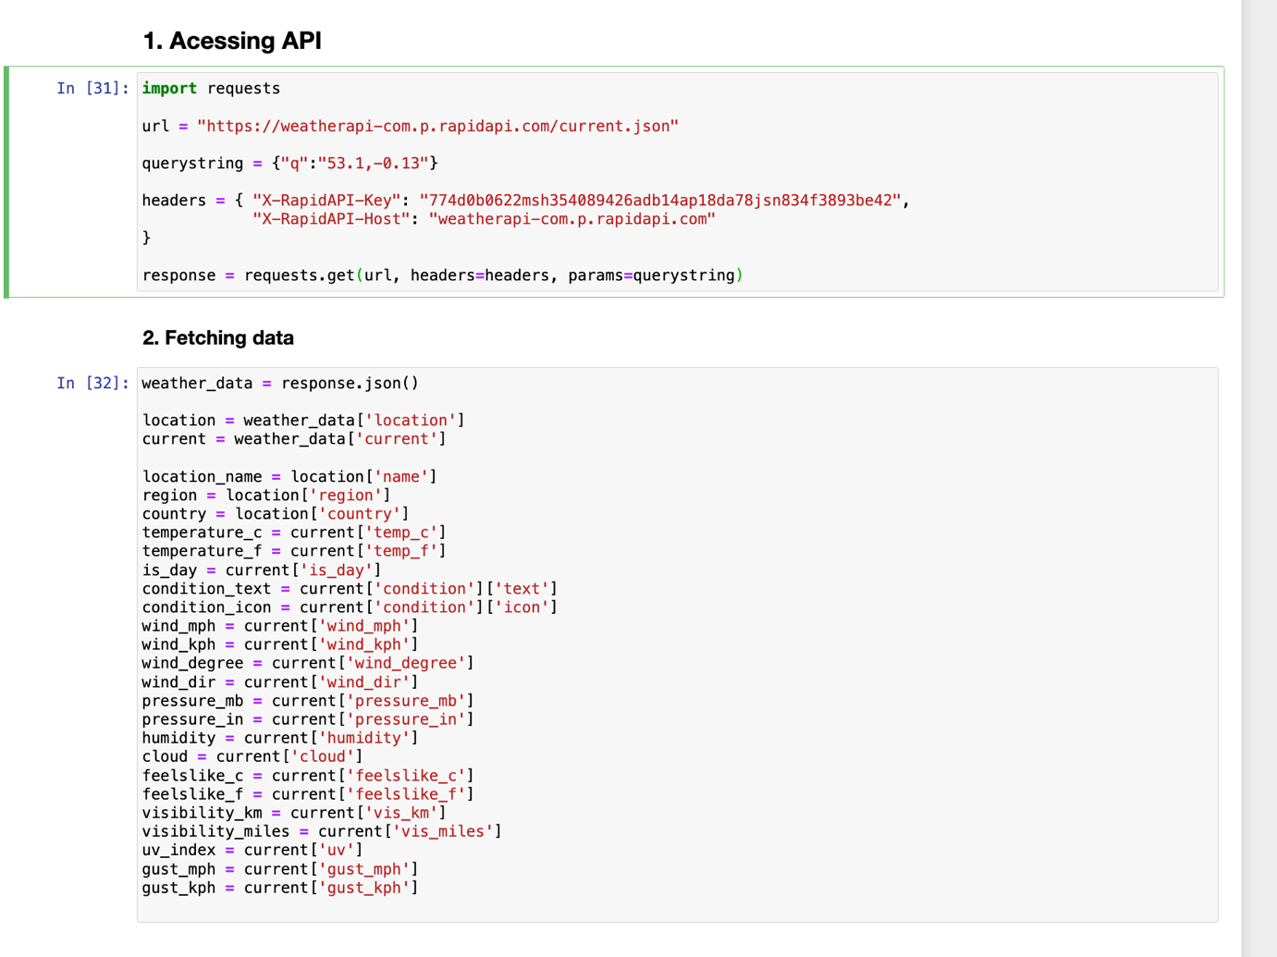

**b)** Displaying data

2 a) set a seed (to ensure work reproducibility) and take a random sample of 25 observations and find the mean Glucose and highest Glucose values of this sample and compare these statistics with the population statistics of the same variable. You should use charts for this comparison.

b) Find the 98th percentile of BMI of your sample and the population and compare the results

using charts.

For the sample: The 98th percentile BMI value is approximately 40.25.

For the population: The 98th percentile BMI value is approximately 47.53.

From these findings, we can observe that the 98th percentile BMI value for the population (47.53) is higher than that of the sample (40.25). This suggests that in the population, there are individuals with higher BMI values compared to the individuals in the sample. It's important to consider the differences in the sample size and the characteristics of the sample when interpreting these percentiles.

C) Using bootstrap (replace= True), create 500 samples (of 150 observation each) from the population and find the average mean, standard deviation and percentile for Blood Pressure and compare this with these statistics from the population for the same variable. Again, you should create charts for this comparison. Report on your findings.

